## Online Car Reservation System

Product Functionalities:

* This provides the feature of booking a car online. It includes several Functionalities as given below.

1. Car Rental Management:

* It provides car Reservation facility online. Customers can visit the website and check for various cars. if they are feasible with the requirement then booking can be done.

1. Checking For different car types:

* Customer must check the car types according to his requirement, whether he wants a 4 or 6 or 8-seater car. If the car is available, then the car is booked for customer

1. Payment:

* The customers must pay the amount for travel. The price is calculated accordingly to the car they have booked.

Requirements for Online Car reservation:

Low Level Requirements:

|  |  |
| --- | --- |
| ID | Description |
| LL_01 | The customer has to register to the website. |
| LL_02 | If the customer is registered, then he must just login. |
| LL_03 | The customer must choose the car according to his requirement. |
| LL_04 | The price of the car for the given kilometers is calculated and bill is generated. |

Table 8 - Low Level Requirements of Online car reservation

High Level Requirement:

|  |  |
| --- | --- |
| ID | Description |
| HL_01 | Registration and login of the customer to the website. |
| HL_02 | The different varieties of the car are shown to the customer through the menu |
| HL_03 | Generation of Bill according to the given kilometers and car type |

Table 9 - High Level Requirements of Online car reservation

Flow Chart:

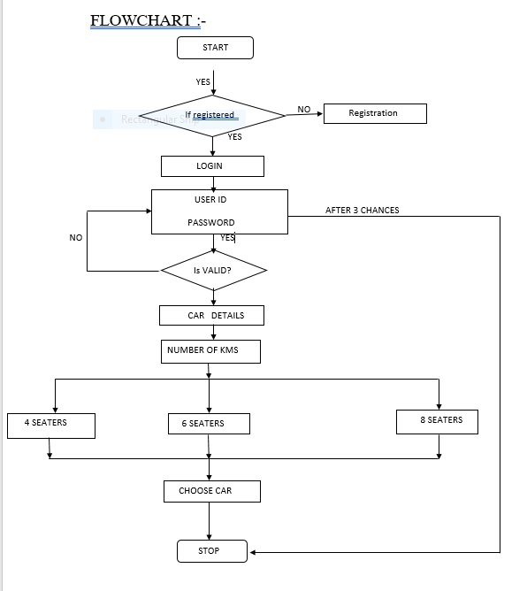

Figure 10 – Flowchart of Online Car reservation

USE CASE DIAGRAM FOR USER:

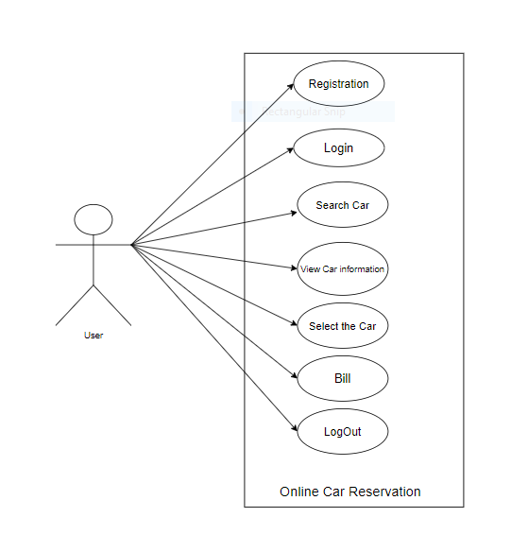

Figure 11: Use Case Diagram for user

Test Plan:

|  |  |  |  |  |
| --- | --- | --- | --- | --- |
| ID | Description | Expected I/p | Expected O/P | Actual O/P |
| TT_01 | Registration | Username & Password | Register | Registered |
| TT_02 | Registration | Invalid Input | Not register | Not registered |
| TT_03 | Login | Valid username & password | login | login |
| TT_04 | login | Invalid username or password | Login unsuccessful | Login unsuccessful |
| TT_05 | Login (if the number of attempts is more than 3) | Username &password | Login unsuccessful | Login unsuccessful |
| TT_06 | Selecting the car type | Selects 4 or 6 or 8-seater car | The required car is allotted | Car is allotted |
| TT_07 | Car type | Selects 4 or 6 or 8-seater car | If the requirement of customer is not available | Car is not allotted |
| TT_08 | Bill | Customer must enter the number of kilometers | Price according to the kilometers & car is generated | Bill generated |

Table 10: Test Plan of Online car Reservation